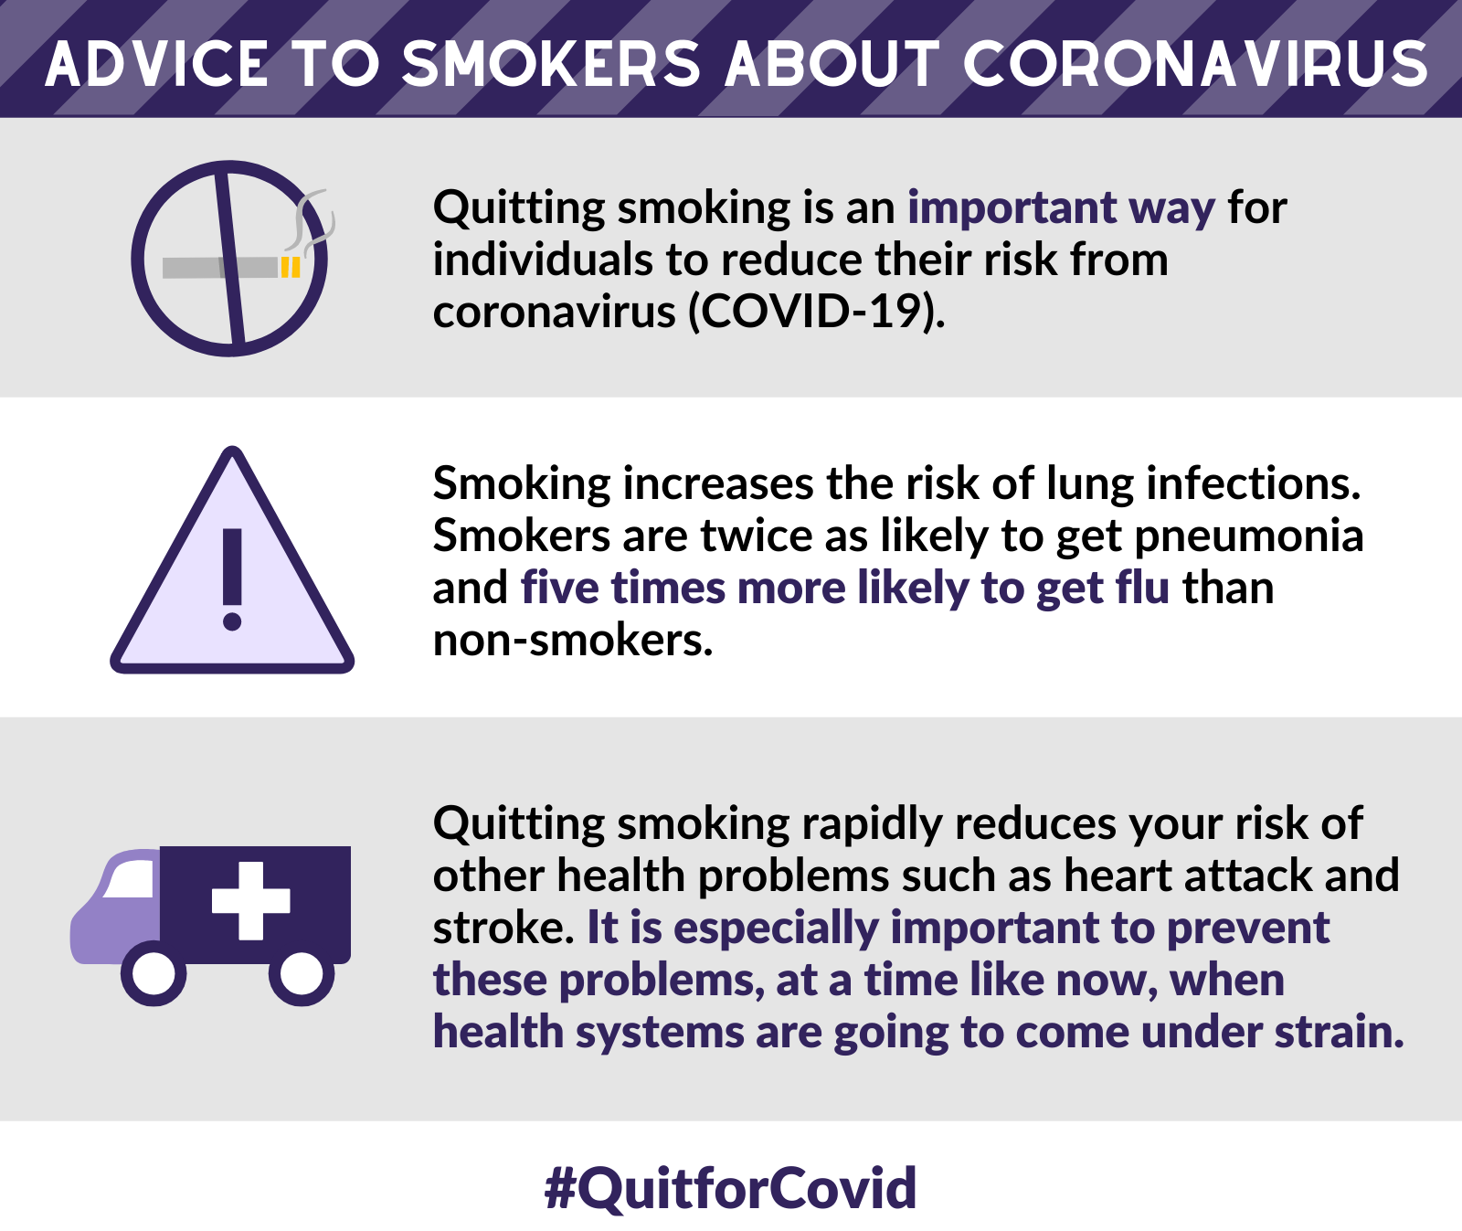

https://www.livewelldorset.co.uk/articles/quit-smoking-for-covid/?utm_source=Facebook&utm_medium=social&utm_campaign=SocialSignIn

Protect your household
You’re helping to protect your family and loved ones from second-hand smoke, reducing their chance of related complications too. Smokers who are self-isolating and are unable to go outside should seek to use alternatives such as nicotine replacement therapy (NRT) or e-cigarettes. Exposure to secondhand smoke increases the risk of complications from respiratory infections.

FREE NRT packs for smokers in Dorset
We’re providing 8-10 weeks of NRT free of charge to help smokers quit smoking. Stopping smoking brings immediate health benefits particularly to the heart and lungs. Reduce your likelihood of added complications from coronavirus.

Ready to quit?
Congratulations, and thank you for committing to make this the time you quit for good. We applaud you! We’re cheering you on! You’re not alone. We’re here for you. We will provide you with telephone coaching from our stop-smoke coaches.
Smokers who register for our smoking cessation support will be able to choose one of three different options available for smokers who would like support to quit smoking:
- 6 x 30-minute telephone coaching sessions with your dedicated smoking cessation coach
- 6 x 30-minute telephone coaching sessions with a dedicated smoking cessation coach AND 8-10 weeks of funded NRT
- Regular email support with a dedicated smoking cessation coach and a 30-minute call four weeks after your quit date AND 8-10 weeks of funded NRT
Our coaching sessions will help you to become smoke-free by supporting you to identify the things you think are preventing you from quitting and working out how you can overcome them. You will also be encouraged to set a quit date as part of your quit attempt.
Our smoking cessation coaches will work with you to work out the right strength of patch and gum for you and will run through how to use each product you are sent. 24-hour patches and gum are on offer for clients who require it to help them quit and will be sent directly to your home from us.

Start your stop-smoke journey
If you are new to LiveWell Dorset, welcome. We support adults in Dorset to take steps to a happier and healthier life. Our free advice and coaching is provided by your council.
Pick up the phone if there’s anything we can do to support you. You can call us on freephone 0800 840 1628. Register to receive our support. Once you’ve registered we’ll call to discuss your stop-smoke plan.

